 **Air University**

(Multan Campus)

|  |
| --- |
| Department of Computer Sciences |
| Software Engineering |
| Git & Github Exercises |
|  |
| **Suheer Tahir** |
| **Roll # 153158** |
| **BSCS-F-15-A-35**  Submitted To: Sir. Ahmad Mohsin  Date: 18 September, 2017 |

|  |
| --- |
|  |

**Exercise 0:**

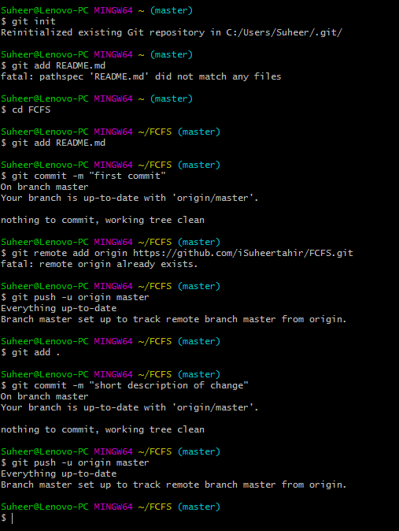

**Exercise 1:**

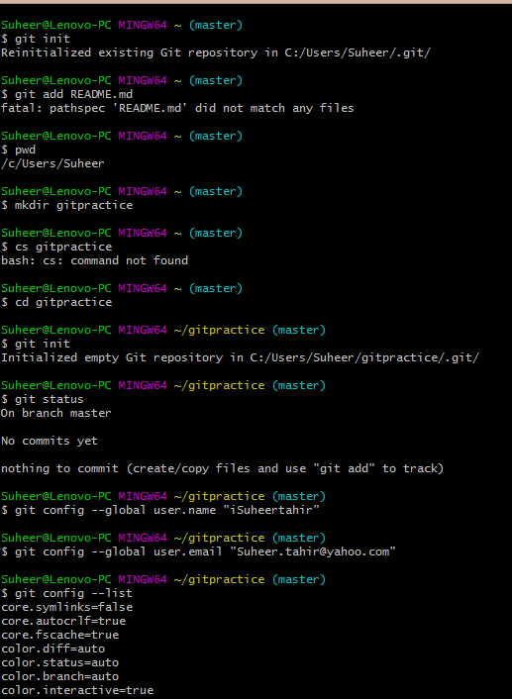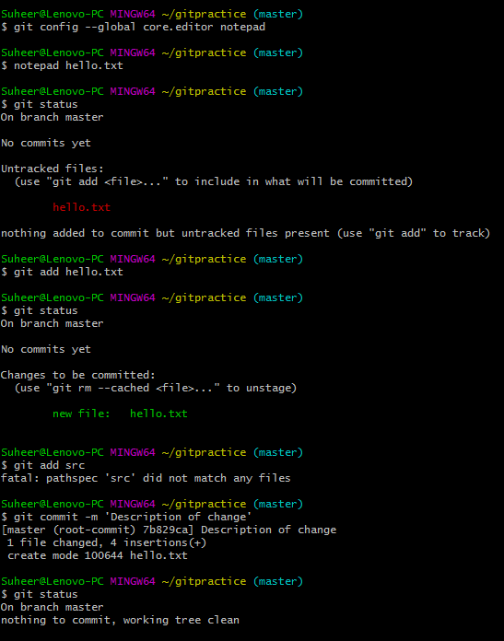



**Exercise 2:**

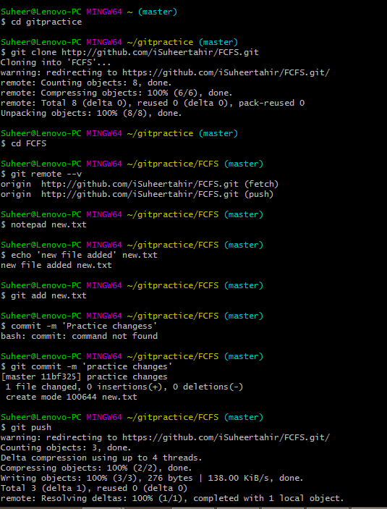

**Exercise 3 & 4:**

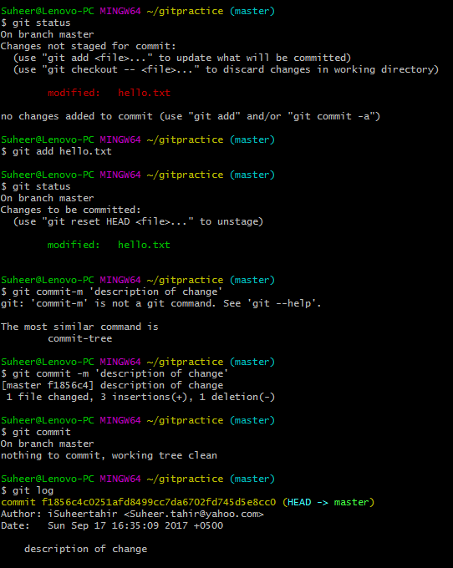

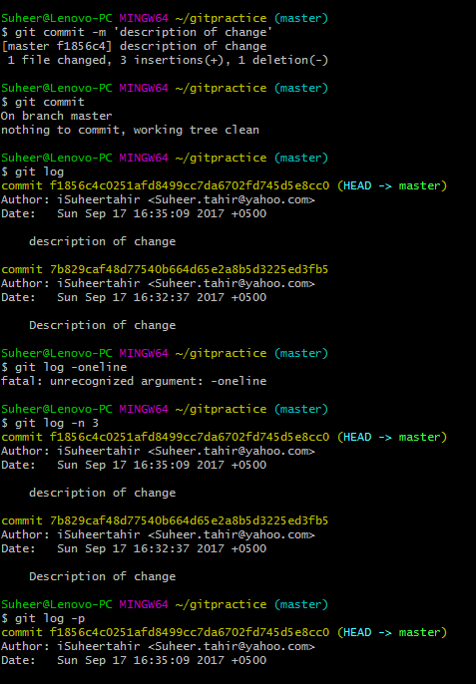

**Exercise 5(Branching and Merging):**

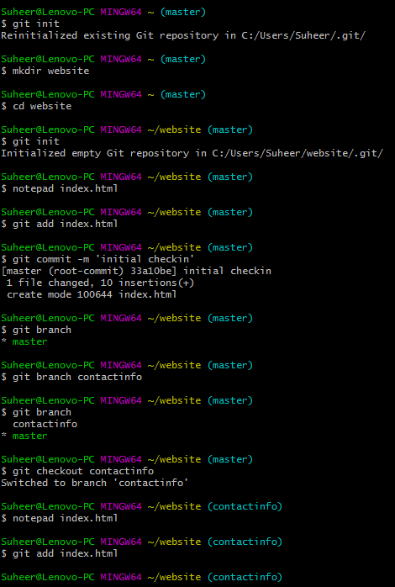

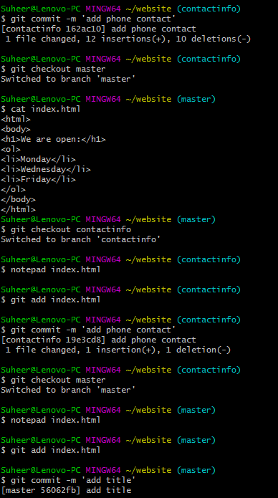

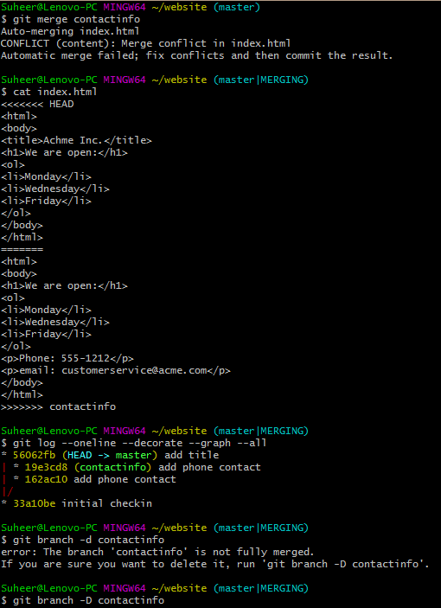

**Exercise 5(Branching and Merging with conflict):**